Loan Default Prediction model
Machine Learning Model Development Report
A Comparative Study of Seven Machine Learning Models for Credit Risk Assessment

GROUP A
FULL NAMES | REGISTRATION NUMBER | STUDENT NUMBER
WALUUBE ALVIN DAVID | 24/U/11805/PS | 2400711805
AKELLO BEATRICE | 24/U/25856/EVE | 2400725856
ASIIMWE ISAAC | 24/U/03765/PS | 2400703765
SEKIBAALA MARK | 24/U11007/PS | 2400711007
AKELLO LILIAN | 24/U/03142/PS | 2400703142

May 2026

Table of Contents
Contents
Table of Contents 2
1.0 Introduction 3
1.1 Background 3
1.2 Problem statement 3
1.3 Suggested solution 3
1.4 Objectives 4
2.0 Methodology 4
2.1 Workflow 4
2.2 Dataset Description 5
2.3 Exploratory Data Analysis 6
2.4 Feature Engineering 11
2.5 Data Preprocessing 12
2.6 Model Development 12
2.7 Model Evaluation 13
3.0 Results 14
3.1 Final Model Performance Summary 14
3.2 Neural Network Training History 15
4.0 Analysis and insight 16
Practical application 16
Challenges faced 17
5.0 Future Work 17
GITHUB REPOSITORY 17

Introduction

1.1 Background

The increasing adoption of digital financial systems has transformed the way financial institutions process and manage loan applications. Banks and lending organizations handle large volumes of applicant data, making manual loan evaluation time-consuming, inconsistent, and prone to human error. Traditional credit assessment methods often rely on fixed rules and subjective judgment, which may fail to accurately identify high-risk borrowers. As a result, financial institutions face challenges such as loan defaults, delayed decision-making, and reduced operational efficiency.

Machine learning provides a modern solution to these challenges by enabling automated analysis of historical financial and customer data to predict loan repayment behavior. By identifying hidden patterns and relationships within data, machine learning models can improve the accuracy, speed, and consistency of loan approval decisions. This project explores the application of different machine learning techniques for predicting loan outcomes and supporting data-driven lending decisions.

1.2 Problem statement

Financial institutions experience difficulties in accurately determining whether loan applicants are likely to repay or default on loans. Incorrect predictions may lead to approving risky applicants, causing financial losses, or rejecting eligible customers, resulting in missed business opportunities. Existing manual and rule-based systems are often inefficient when dealing with large and complex datasets. Therefore, there is a need for an intelligent predictive system capable of improving the accuracy and reliability of loan approval decisions.

1.3 Suggested solution

To address the problem, this project proposes the use of supervised machine learning techniques for automated loan prediction. Several models were trained and evaluated to compare their predictive performance and reliability. The models used include:

Dummy Classifier (Majority) — a naive baseline model.

Decision Tree (Tuned) — a pruned single-tree classification model.

Decision Tree (CCP) — a cost-complexity pruned decision tree.

Random Forest (Tuned) — an ensemble learning model using multiple decision trees.

XGBoost (Optuna) — an extreme gradient boosting model optimized using Bayesian tuning.

LightGBM (Optuna) — a light gradient boosting framework optimized using Bayesian tuning.

Neural Network (Optuna) — a deep learning model optimized using Bayesian tuning.

1.4 Objectives

The main objective of this project is to develop and evaluate machine learning models for loan prediction.

The specific objectives include;

To preprocess and prepare loan application data for analysis.

To perform feature engineering and data transformation to improve predictive performance

To train and evaluate seven machine learning models for loan prediction

To compare the performance of multiple models using appropriate evaluation metrics

To identify the most accurate and reliable model for predicting loan outcomes

2.0 Methodology
This section describes the methodology followed in developing the loan prediction system. The project was approached as a binary classification task aimed at predicting loan outcomes using historical lending data obtained from the Lending Club dataset. The implementation and experimentation were carried out using Google Colab as the development environment. The methodology included data preprocessing, feature engineering, exploratory data analysis, model training, hyperparameter optimization, and performance evaluation. Several machine learning and deep learning models were trained and compared in order to identify the most accurate and reliable model for loan prediction.

2.1 Workflow
The project followed a supervised binary classification workflow designed to predict loan default. The pipeline consisted of the following sequential stages:
- Data Acquisition and Inspection
- Exploratory Data Analysis (EDA)
- Feature Engineering and Selection
- Data Preprocessing and Cleaning
- Model Development and Training
- Hyperparameter Optimisation (Optuna)
- Model Evaluation and Comparison
- Interpretation and Reporting

This structured workflow ensured consistency across all models and enabled fair comparison of their predictive performance on the same dataset and evaluation conditions.
Resource usage on Google Colab
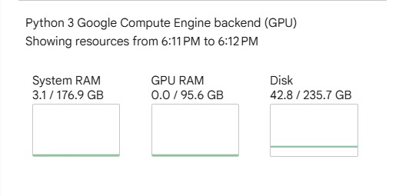

2.2 Dataset Description
2.2.1 Data Source
The dataset used in this project is the publicly available LendingClub loan data hosted on Kaggle, covering loan issuances from 2007 to 2018. It contains detailed information on borrower demographics, credit history, loan terms, and repayment outcomes. The raw dataset comprises over 1.38 million loan records with more than 150 features per record.
2.2.2 Target Variable
The target variable is a binary classification label derived from the loan status field:
- 0 — Fully Paid: the borrower repaid the loan in full
- 1 — Default / Charged Off: the borrower failed to repay the loan

The dataset exhibits class imbalance, with the majority of loans fully repaid. This imbalance was addressed during model training through appropriate class weighting and evaluation metric selection.

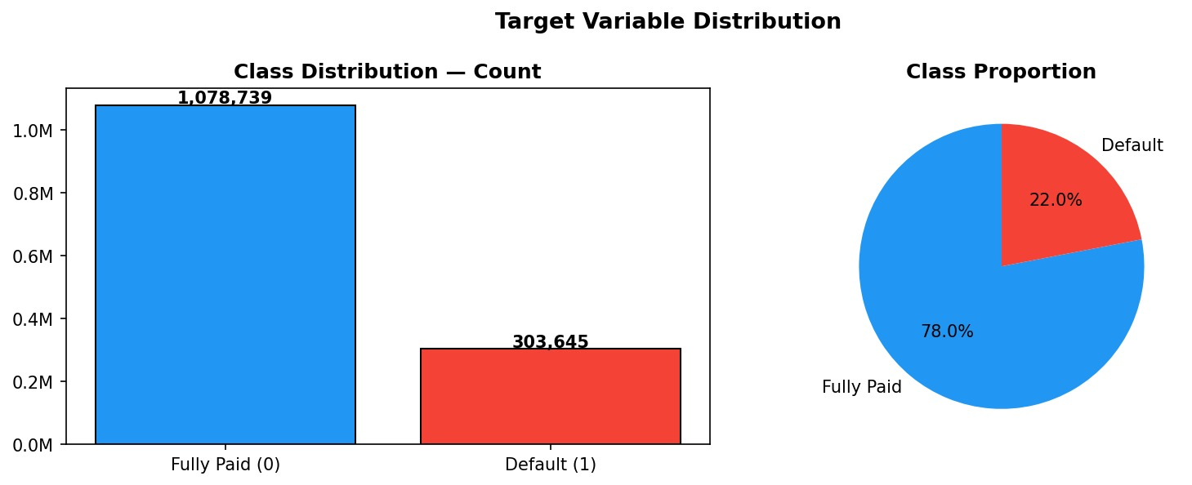
Figure 1: Target Variable Distribution — Class Count (left) and Class Proportion (right). The dataset contains 1,078,739 fully paid loans (78%) and 303,645 defaulted loans (22%).

2.3 Exploratory Data Analysis
Exploratory Data Analysis (EDA) was conducted to understand the distribution of key features, identify patterns related to default risk, and inform feature engineering and preprocessing decisions.

2.3.1 Raw Numeric Feature Distributions
An initial inspection of the raw numeric features revealed significant skewness in several key variables. Loan amount (skew=0.78) and installment (skew=1.00) follow right-skewed distributions, with most loans concentrated at lower amounts. Interest rate (skew=0.77) shows a multimodal distribution, reflecting LendingClub's grade-based rate tiers. Annual income (skew=493.89) and debt-to-income ratio (skew=29.20) exhibit extreme right skew, indicating the presence of high-income outliers and a small number of borrowers with very high debt burdens. These distributions informed the log-transformation and outlier-capping steps applied during preprocessing.

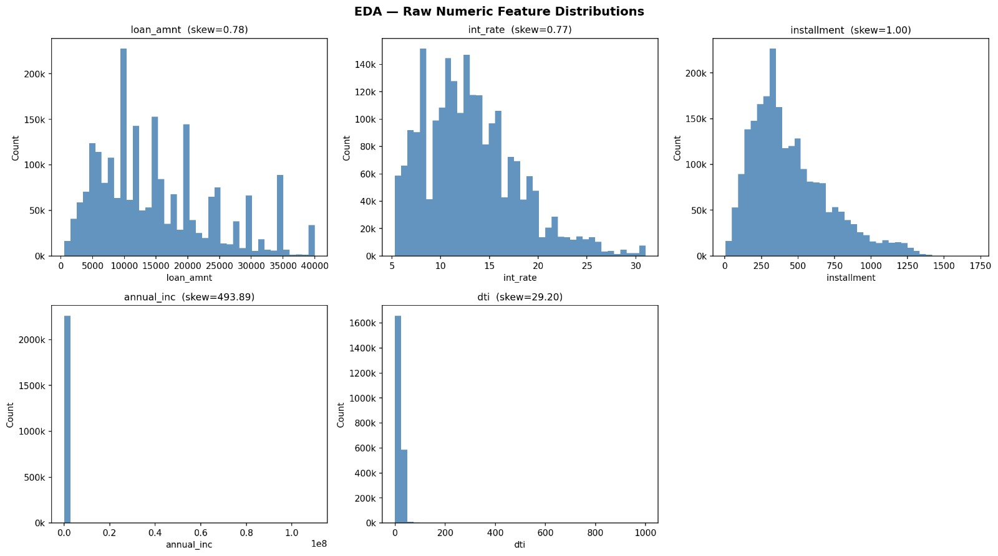
Figure 2: EDA — Raw Numeric Feature Distributions. Notable right skew in annual income (skew=493.89) and DTI (skew=29.20) required log-transformation prior to modelling.

2.3.2 Feature Correlation Heatmap
A correlation heatmap was computed for the primary numeric features to identify multicollinearity and relationships with the target variable (is_bad). The strongest correlation observed was between loan amount and installment (r=0.95), which is expected as installment size is a direct function of loan amount. Interest rate showed the highest correlation with default risk (r=0.26), confirming its importance as a predictor. Annual income showed a weak negative correlation with default (r=-0.04), while debt-to-income ratio showed a modest positive relationship (r=0.08). The loan amount–installment multicollinearity was addressed through feature selection during preprocessing.

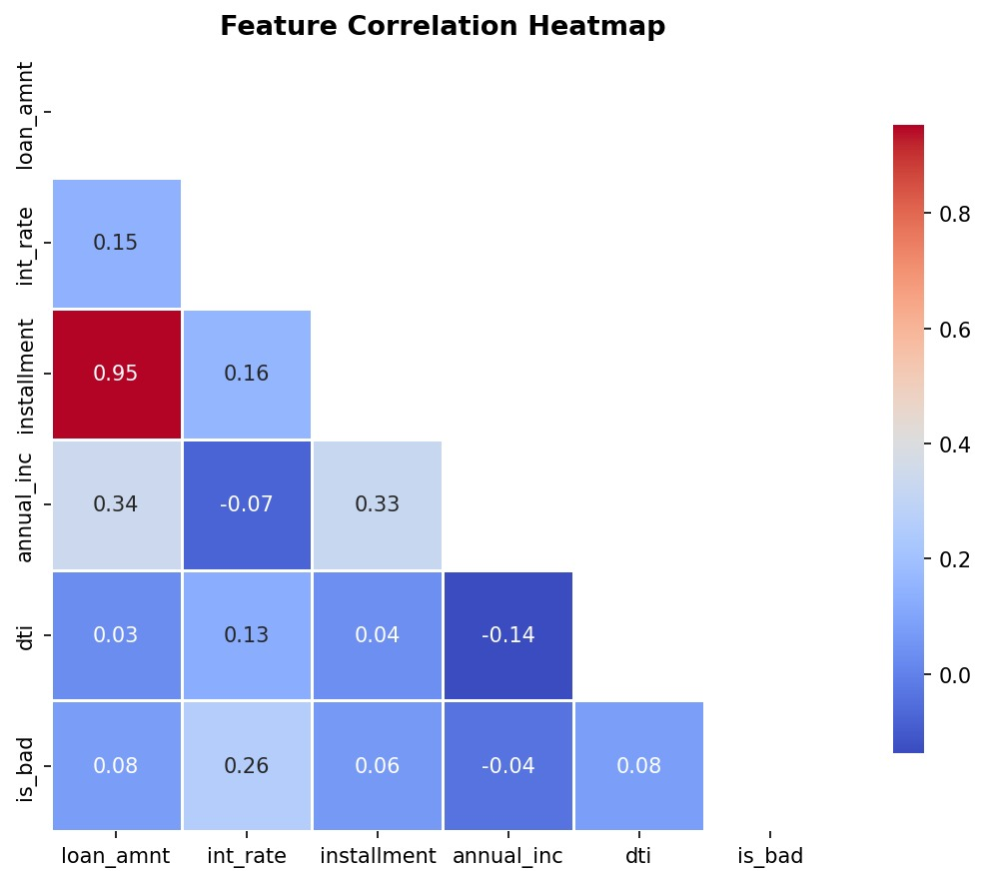
Figure 3: Feature Correlation Heatmap. The strong loan_amnt–installment correlation (0.95) indicates multicollinearity; interest rate shows the strongest relationship with default (is_bad = 0.26).

2.3.3 Loan Amount vs. Interest Rate by Grade
A scatter plot of loan amount against interest rate, coloured by LendingClub loan grade, reveals the platform's structured grade-based pricing system. Grade A loans consistently receive the lowest interest rates (approximately 5–10%), while Grade G loans attract rates of 25–31%. Loan amount shows no strong linear relationship with interest rate within a given grade, confirming that grade is the primary determinant of rate rather than loan size. This visualisation validated the inclusion of sub_grade_numeric as an engineered feature.

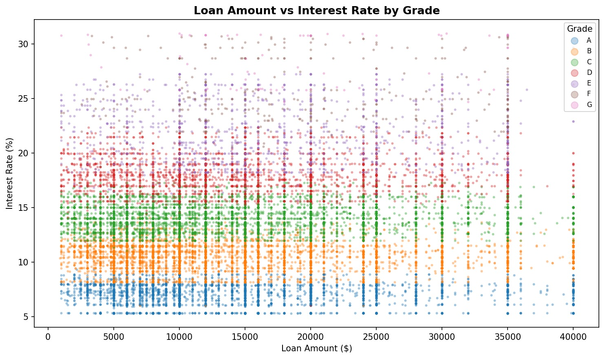
Figure 4: Loan Amount vs. Interest Rate by Grade. The clear horizontal banding by grade confirms that loan grade is the primary driver of interest rate assignment on the LendingClub platform.

2.3.4 FICO Score Distribution by Loan Outcome
The FICO credit score is one of the most important indicators of borrower creditworthiness. Analysis of the FICO score distribution by loan outcome revealed that defaulted loans tend to cluster at lower FICO scores, while fully paid loans show a broader distribution extending to higher scores.

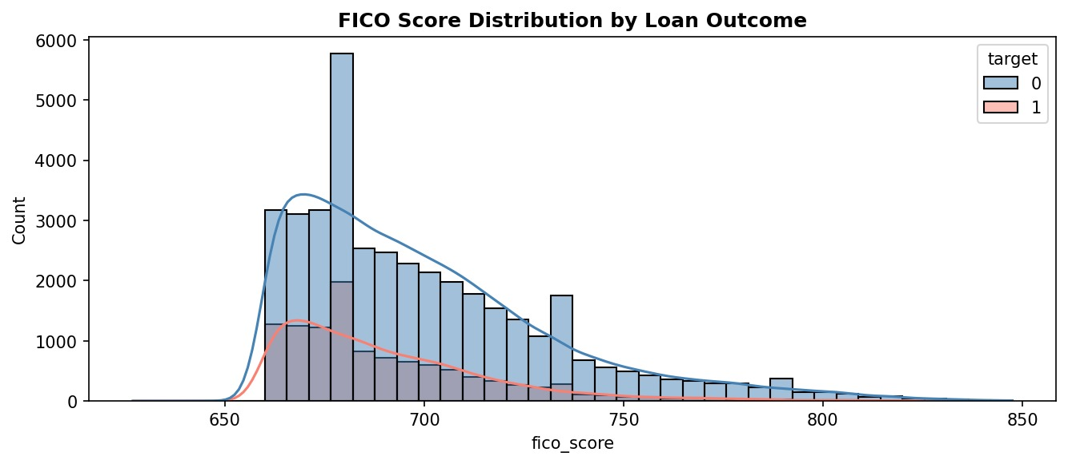
Figure 5: FICO Score Distribution by Loan Outcome. Borrowers who defaulted (target=1) show a concentration at lower FICO scores compared to fully paid borrowers (target=0).

2.3.5 Interest Rate vs. Loan Outcome
Interest rates assigned to loans reflect LendingClub's internal risk assessment. Defaulted loans carry noticeably higher median interest rates than fully paid loans, confirming that higher-rate loans represent riskier borrowers. The interquartile range (IQR) for defaulted loans spans approximately 13% to 19%, compared to 10% to 15% for fully paid loans.

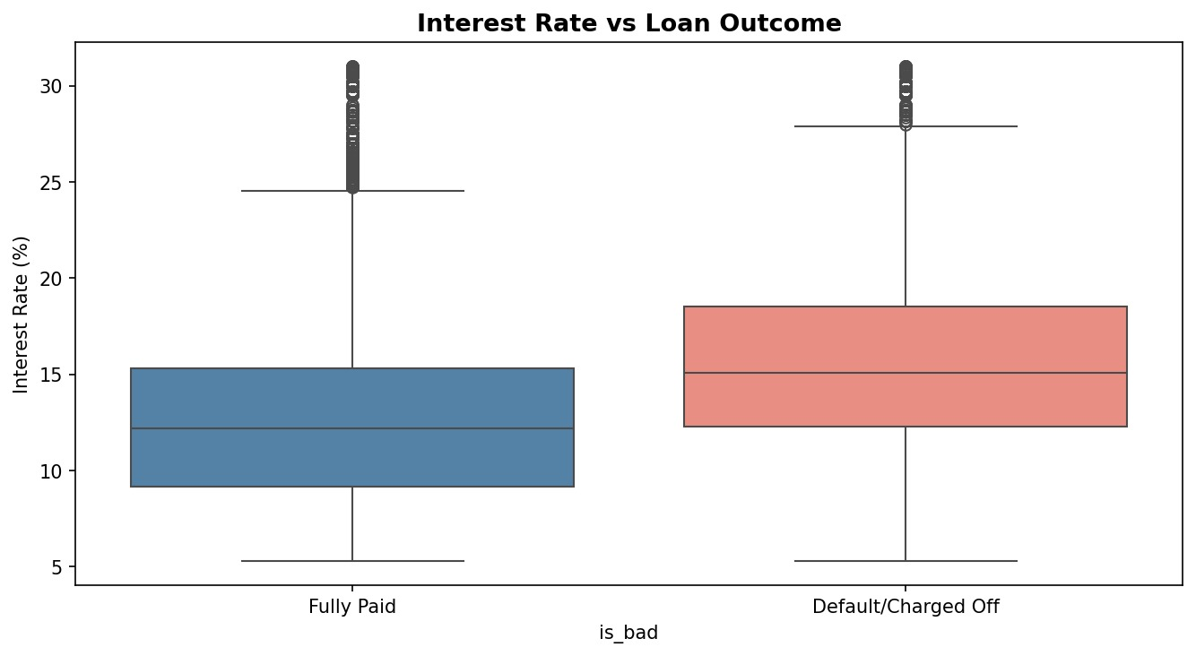
Figure 6: Interest Rate Distribution by Loan Outcome. Loans that defaulted or were charged off (right) show consistently higher interest rates than fully paid loans (left).

2.3.6 Employment Length Distribution
Employment length was analysed prior to imputation to understand missing value patterns and the overall distribution. The majority of borrowers report 10 or more years of employment, suggesting this category is over-represented. Shorter employment tenures show relatively uniform counts ranging from approximately 50,000 to 130,000 borrowers.

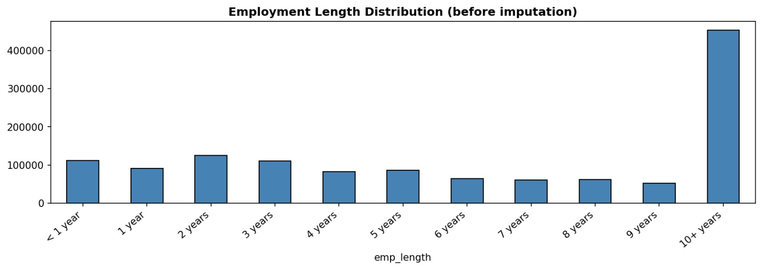
Figure 7: Employment Length Distribution (before imputation). The '10+ years' category dominates with over 450,000 records.

2.3.7 Temporal Analysis (2007–2018)
A temporal analysis was conducted to assess how default rates and loan origination volumes evolved over the dataset's time horizon. Default rates were highest in the early years (2007–2009), peaking above 30%, coinciding with the 2008 financial crisis. After a recovery period, default rates gradually rose again from 2013 onwards, reaching approximately 27–30% by 2016–2017. Loan origination volume grew exponentially from near zero in 2007 to a peak of approximately 50,000 loans per month in 2016, before declining into 2018.

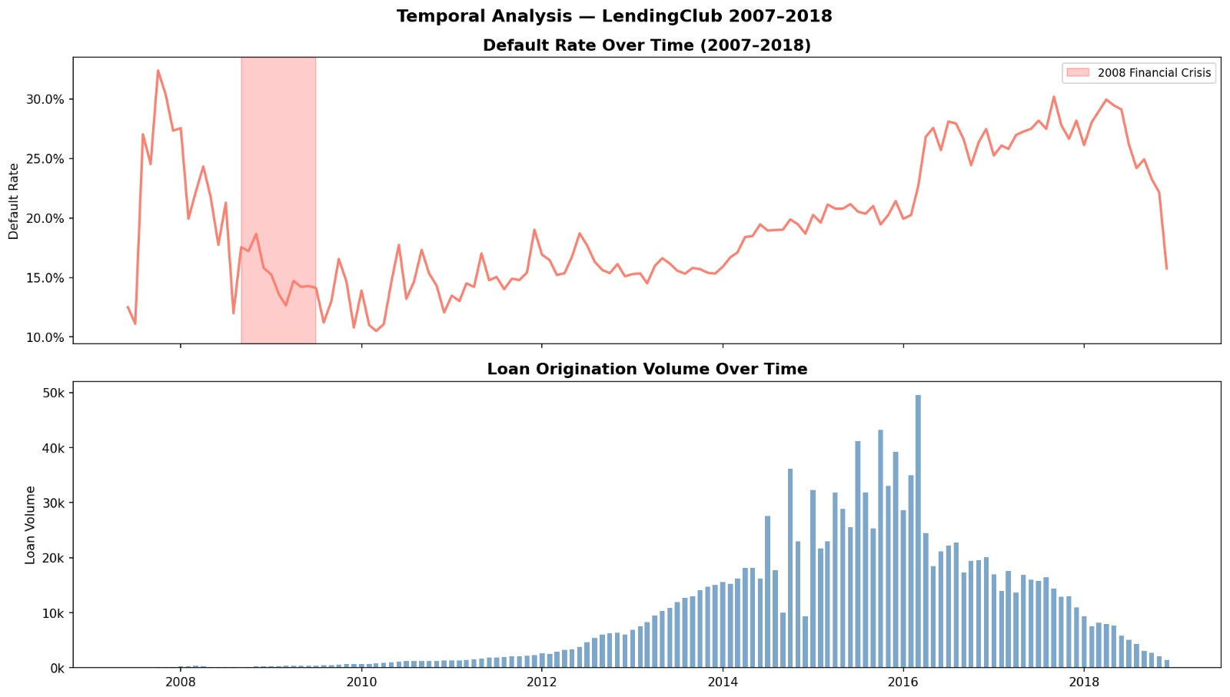
Figure 8: Temporal Analysis — Default Rate Over Time (top) and Loan Origination Volume (bottom), 2007–2018. The shaded region highlights the 2008 Financial Crisis period.

2.4 Feature Engineering
Feature engineering was performed to extract additional predictive signal from the raw data. The following engineered features were constructed from the raw LendingClub variables:

Feature Name | Description
cr_history_months | Length of the borrower's credit history in months
sub_grade_numeric | Numerical encoding of LendingClub loan sub-grade (A1–G5 → integer)
fico_score | Representative FICO credit score of the borrower
has_delinq | Binary: whether the borrower has any delinquent accounts
bal_to_inc_ratio | Ratio of total account balances to annual income
acc_active_ratio | Ratio of active accounts to total credit accounts
recent_acc_ratio | Ratio of recently opened accounts to total accounts
has_coll_bal | Binary: whether the borrower has any collection balances outstanding
pub_rec_flag | Binary: whether the borrower has public records (e.g., bankruptcy, liens)
is_homeowner | Binary: whether the borrower owns a home
avg_rev_age_years | Average age of revolving credit accounts in years

These engineered features capture hidden financial risk patterns, represent creditworthiness more effectively than raw inputs, and reduce noise in model learning. For example, bal_to_inc_ratio directly measures financial burden relative to income, while has_delinq quickly flags borrowers with a history of payment problems. The sub_grade_numeric encoding preserves the ordinal risk ordering implicit in LendingClub's grading system.

2.5 Data Preprocessing
2.5.1 Missing Value Handling
Missing values were addressed using appropriate imputation strategies. Numerical features with limited missingness were imputed using median values to avoid the influence of outliers. Categorical features were imputed with the mode. The employment length feature, which had a notable proportion of missing values, was imputed prior to ordinal encoding.
2.5.2 Skewness Correction and Outlier Handling
Given the extreme skewness observed in annual_inc (skew=493.89) and dti (skew=29.20), log-transformation was applied to these features after capping outliers at the 99th percentile. This normalised the distributions and improved model convergence for gradient-based methods.
2.5.3 Encoding and Scaling
Categorical variables such as loan purpose, home ownership status, and loan grade were encoded using ordinal or one-hot encoding as appropriate. Numerical features were standardised using StandardScaler to ensure a mean of zero and unit variance, which is particularly important for the neural network model.
2.5.4 Class Imbalance
Given the 78:22 class imbalance (fully paid vs. default), class weights were assigned inversely proportional to class frequencies during model training. The Precision-Recall AUC (PR-AUC) and F1-Macro score were used as primary evaluation metrics, as they are more informative than ROC-AUC under class imbalance conditions.
2.5.5 Data Splitting
The dataset was split into training, validation, and test sets using a time-aware strategy to prevent data leakage: loans issued in earlier years were used for training and validation, while later loans formed the held-out test set. An approximate 70/15/15 split was used.

2.6 Model Development
2.6.1 Dummy Classifier (Majority Baseline)
A majority-class dummy classifier was used as the naive baseline. It always predicts the majority class (Fully Paid), providing a lower-bound benchmark against which all other models were compared.
2.6.2 Decision Tree Models
Two decision tree variants were trained. The first used standard hyperparameter tuning (max depth, min samples leaf) to prevent overfitting. The second applied Cost-Complexity Pruning (CCP) using the optimal alpha value determined by cross-validation, which produces a sparser tree with better generalisation by systematically removing subtrees that provide minimal impurity reduction.
2.6.3 Random Forest (Tuned)
A Random Forest is an ensemble of decision trees trained on random subsets of the data and features, with predictions made by majority vote. Hyperparameters (number of trees, max features, max depth, min samples leaf) were tuned using grid search with cross-validation. Class weights were set to 'balanced' to address the target imbalance. Random Forest achieved the highest F1-Macro score among all models evaluated.
2.6.4 XGBoost and LightGBM (Optuna)
XGBoost (Extreme Gradient Boosting) and LightGBM (Light Gradient Boosting Machine) are high-performance gradient boosting frameworks well-suited for tabular financial data. Both models were tuned using Optuna, a Bayesian hyperparameter optimisation framework that efficiently explores the hyperparameter space using Tree-structured Parzen Estimator (TPE) sampling. LightGBM achieved the highest PR-AUC (0.4424) and ROC-AUC (0.7381) among all models.
2.6.5 Neural Network (Optuna)
A fully connected feedforward neural network was developed using PyTorch. The architecture comprised an input layer, two hidden layers with ReLU activation and Batch Normalisation, Dropout regularisation after each hidden layer, and a single sigmoid output neuron for binary classification. The Adam optimiser with Binary Cross-Entropy Loss was used. Hyperparameters including learning rate, hidden layer sizes, and dropout rate were tuned using Optuna. The model was trained for 20 epochs with early stopping based on validation PR-AUC.

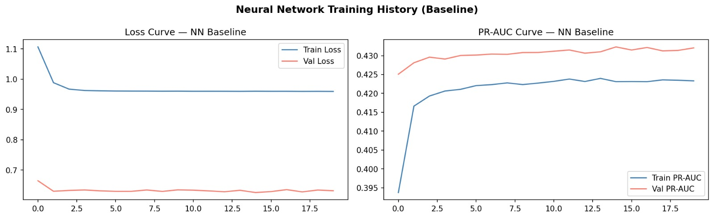
Figure 9: Neural Network Training History — Loss Curve (left) and PR-AUC Curve (right). The validation PR-AUC stabilises at approximately 0.431, indicating effective learning without significant overfitting.

2.7 Model Evaluation
Model performance was evaluated using the following metrics, all computed on the held-out test set:

Metric | Description | Why It Matters
F1-Macro | Harmonic mean of precision & recall, averaged across both classes | Balances performance on both majority and minority class
AUC-ROC | Area under the Receiver Operating Characteristic curve | Measures overall discriminative ability across all thresholds
PR-AUC | Area under the Precision-Recall curve | Most informative under class imbalance; focuses on minority (default) class
Brier Score | Mean squared error of predicted probabilities | Measures probability calibration quality; lower is better

3.0 Results

3.1 Final Model Performance Summary
The performance of all seven models was compared across the four evaluation metrics. Results are reported on the held-out test set. The table below presents the complete final performance summary, with the best-performing model highlighted.

Model | F1-Macro | AUC-ROC | PR-AUC | Brier Score
Random Forest (Tuned) | 0.6392 | 0.7292 | 0.4272 | 0.1751
XGBoost (Optuna) | 0.6203 | 0.7376 | 0.4420 | 0.2034
LightGBM (Optuna) | 0.6168 | 0.7381 | 0.4424 | 0.2062
Decision Tree (CCP) | 0.6050 | 0.6926 | 0.3545 | 0.2224
Neural Network (Optuna) | 0.5959 | 0.7270 | 0.4256 | 0.2162
Decision Tree (Tuned) | 0.5948 | 0.7090 | 0.3925 | 0.2177
Dummy (Majority) | 0.4383 | 0.5000 | 0.2196 | 0.1714

The actual model performance output, captured directly from the training pipeline, is shown below:

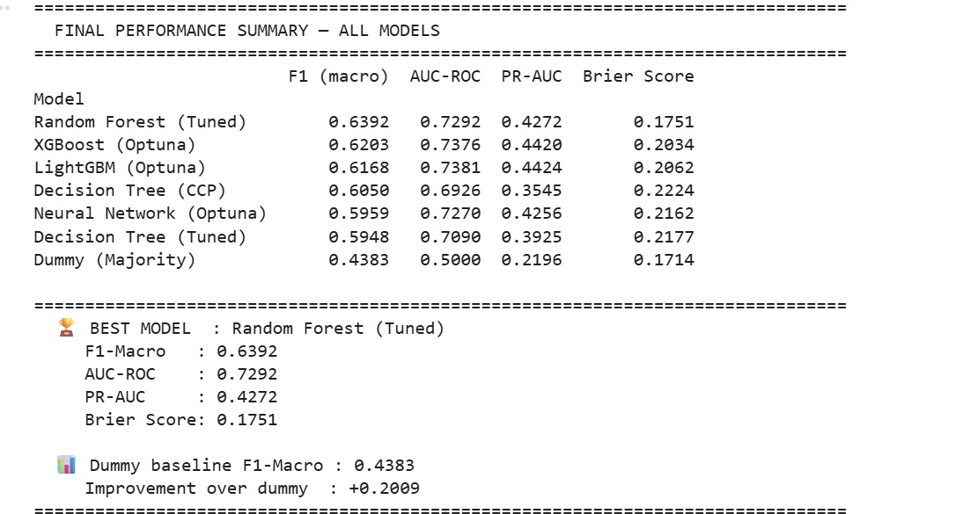
Figure 10: Final Performance Summary — All Models. Random Forest (Tuned) achieved the highest F1-Macro of 0.6392, representing a +0.2009 improvement over the dummy baseline.

Random Forest (Tuned) achieved the highest F1-Macro score of 0.6392, making it the recommended model. It represents a +0.2009 improvement in F1-Macro over the majority-class dummy baseline (0.4383), confirming meaningful predictive value. However, the gradient boosting models (XGBoost and LightGBM) outperformed Random Forest on PR-AUC and AUC-ROC, suggesting they may be preferable in contexts where ranking borrowers by probability of default is more important than a balanced classification threshold.

Key observations from the results:
- Random Forest excels at balanced classification (highest F1-Macro = 0.6392) and achieves the best probability calibration (lowest Brier Score = 0.1751 among non-dummy models)
- LightGBM and XGBoost achieve the best discrimination ability (PR-AUC: 0.4424 and 0.4420; AUC-ROC: 0.7381 and 0.7376), making them preferable for probability ranking tasks
- The Neural Network (Optuna) performs competitively on AUC-ROC (0.7270) but falls below the gradient boosting models on F1-Macro and PR-AUC
- Decision Tree models underperform ensemble methods as expected, with CCP pruning providing moderate improvement over standard tuning
- The Dummy baseline, despite a surprisingly low Brier Score (0.1714), achieves AUC-ROC of only 0.5000, confirming it has no genuine discriminative ability

3.2 Neural Network Training History
The training history of the Optuna-tuned Neural Network was monitored throughout the 20-epoch training run. Both training loss and validation loss, as well as training and validation PR-AUC, were tracked per epoch to assess learning dynamics and detect overfitting.

The loss curve shows rapid convergence within the first 2–3 epochs, with training loss declining steeply from 1.10 to approximately 0.96. Validation loss remains consistently lower (~0.65), indicating that the model generalises well to unseen data. The PR-AUC curve confirms steady improvement in discriminative performance, with the validation PR-AUC consistently exceeding the training PR-AUC throughout training — a positive sign given the class imbalance and class-weighted loss function in use.

4.0 Analysis and insight
This project set out to develop and evaluate machine learning models capable of predicting loan default on the LendingClub dataset (2007–2018). Using a dataset of over 1.38 million loan records, seven supervised learning models were trained and compared across four performance metrics: F1-Macro, AUC-ROC, PR-AUC, and Brier Score.

The results demonstrate that Random Forest (Tuned) achieved the highest overall predictive performance with an F1-Macro of 0.6392, representing a +0.2009 improvement over the naive majority-class baseline. Gradient boosting models (LightGBM and XGBoost with Optuna tuning) achieved the strongest discriminative ranking performance, with LightGBM attaining the highest PR-AUC of 0.4424 and AUC-ROC of 0.7381. All ensemble methods substantially outperformed the single decision tree models and the neural network, confirming that ensemble approaches are particularly well-suited to this tabular credit risk problem.

Feature engineering played a critical role in model performance. Derived features such as the balance-to-income ratio, FICO score, sub-grade encoding, and delinquency indicators provided meaningful additional signal beyond the raw loan attributes. Exploratory analysis further revealed the importance of temporal context (default rates spiked during the 2008 financial crisis), loan grade as the primary determinant of interest rate, and the strong multicollinearity between loan amount and installment that required careful preprocessing.

These findings demonstrate that machine learning, applied rigorously to structured financial data with careful feature engineering, class-imbalance handling, and Bayesian hyperparameter optimisation, can meaningfully support credit risk assessment. With further development, such a system could be integrated into a real-time loan origination pipeline to assist underwriters in making more informed, consistent, and auditable lending decisions.

Practical application
The developed loan prediction model can be practically applied within financial institutions to support automated loan approval and credit risk assessment. Once deployed, the model can analyse applicant information such as income, employment status, loan amount, credit history, debt ratio, and other financial indicators to predict whether a borrower is likely to repay or default on a loan.
In a real-world environment, the model can be integrated into a bank’s loan management system or online loan application platform. When a customer submits a loan application, the system preprocesses the applicant’s data and passes it to the trained model, which then generates a prediction outcome. Based on the prediction, the institution can classify applicants as low-risk or high-risk borrowers and make faster, more consistent lending decisions.
The model can also help reduce manual workload, improve operational efficiency, minimize financial losses caused by defaults, and enhance customer experience by speeding up loan processing times. Additionally, financial institutions can continuously retrain the model using new customer data to improve prediction accuracy and adapt to changing borrower behavior over time.

Challenges faced

5.0 Future Work
Future work will focus on several key areas to further improve model performance and practical deployability:

- Stacking and Blending: develop a meta-learner that combines predictions from Random Forest, LightGBM, and XGBoost to leverage their complementary strengths
- Advanced Architectures: experiment with gradient-boosted neural networks (TabNet, NODE) and transformer-based models designed specifically for tabular data
- Probability Calibration: apply Platt scaling or isotonic regression to ensure predicted default probabilities are well-calibrated for risk-based decision thresholds and regulatory reporting
- Fairness Analysis: assess model predictions across demographic attributes to ensure responsible lending compliance with fair lending regulations
- Explainability: integrate SHAP (SHapley Additive exPlanations) values to provide per-prediction feature attributions, enabling loan officers to understand and audit individual model decisions
- Expanded Feature Engineering: incorporate macroeconomic indicators (unemployment rate, GDP growth, interest rate environment) as time-varying features to improve temporal robustness
- Production Deployment: containerise the best-performing model using Docker and deploy as a REST API for integration into a loan origination system, with A/B testing against incumbent underwriting rules
- Monitoring: implement data drift detection and model performance monitoring to detect degradation as economic conditions and borrower behaviour evolve over time

GITHUB REPOSITORY

VIDEO

